University of Wolverhampton
School of Mathematics and Computer Science
Student Number:
Name:2407710
6CS005 High Performance Computing Week 3 Workshop
Revision on Multithreading
Tasks – Multithreading

You will need to refer to the Week 3 lecture sides in order to complete these tasks.
- Write a multithreaded C program to print out all the prime numbers between 1 to 10000. Use exactly 3 threads.
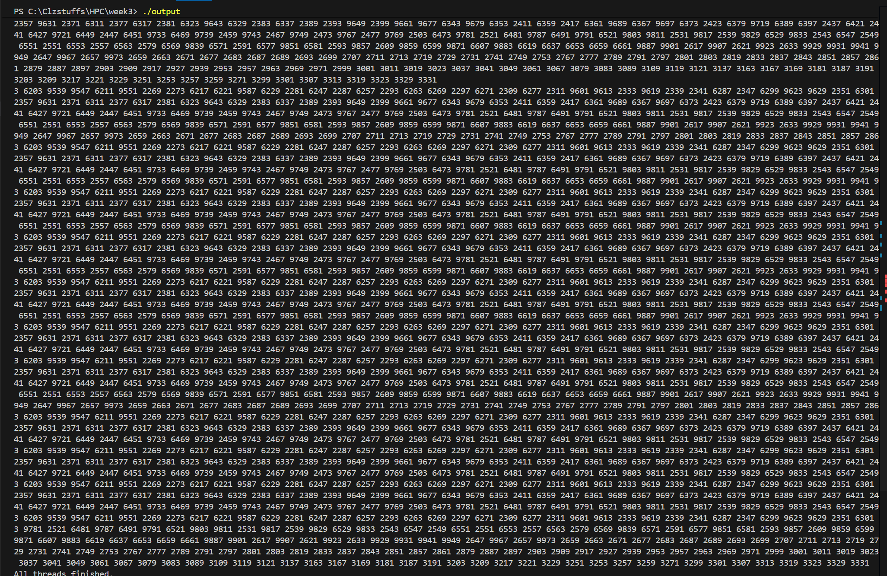
- Convert this program to prompt the user for a number and then to create the number of threads the user has specified to find the prime numbers.
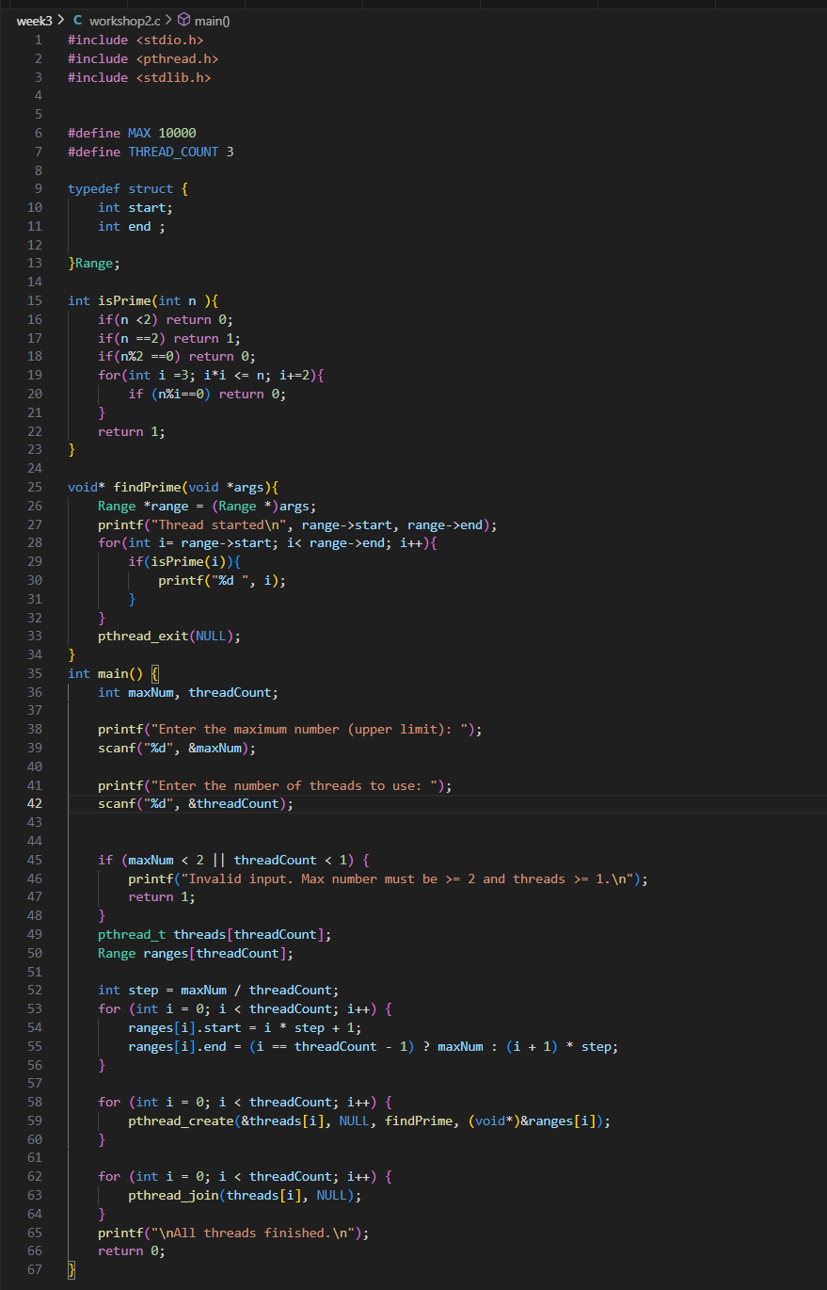
Output
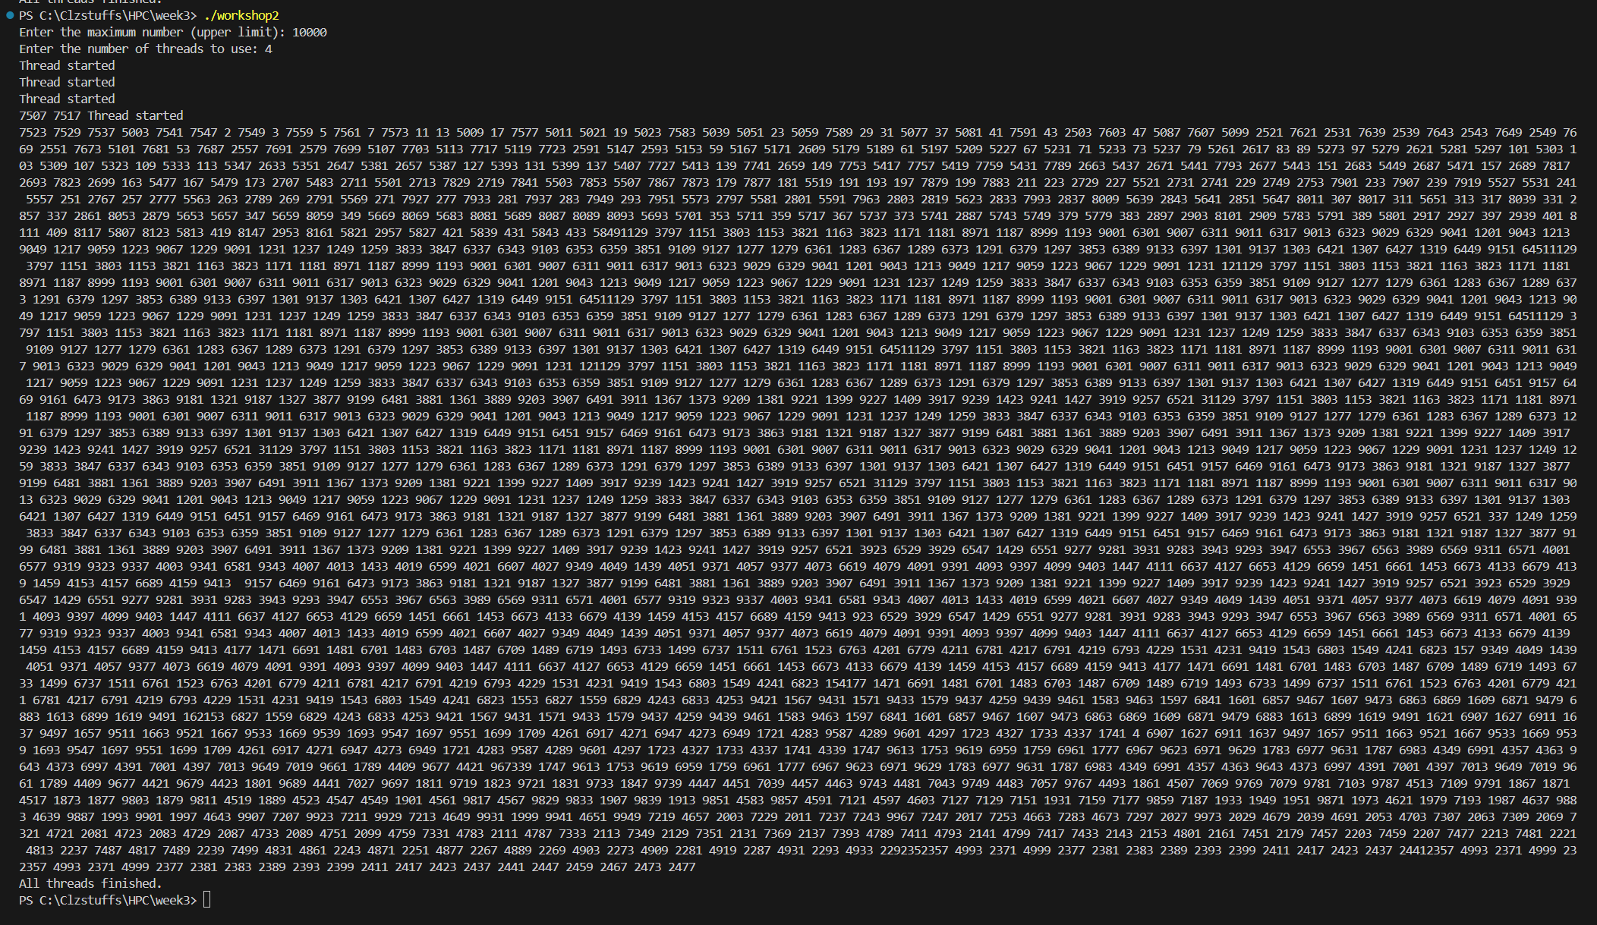
- Convert the program in (2) so that each thread returns the number of prime numbers that it has found using pthread_exit() and for main program to print out the number of prime number that each thread has found.
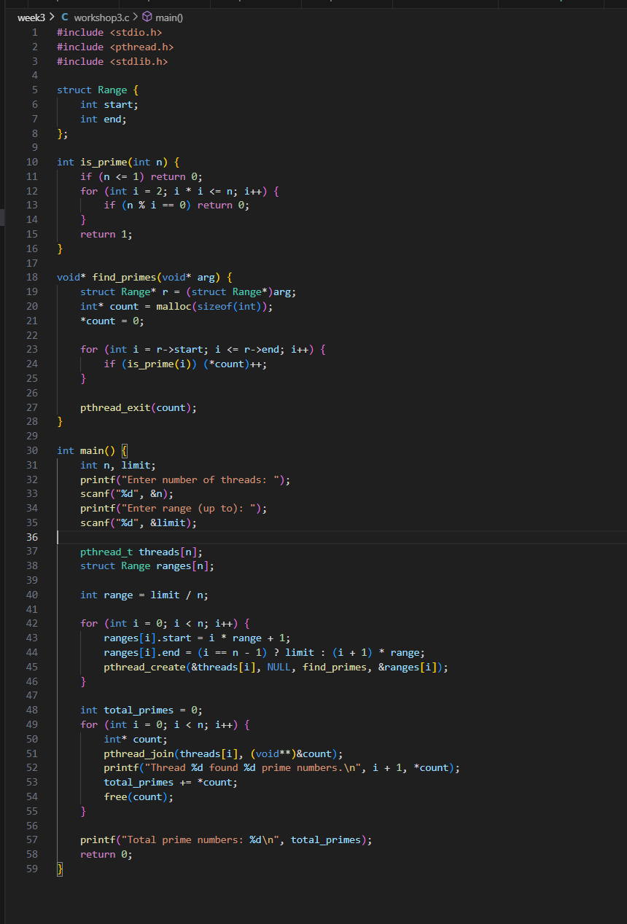
Output
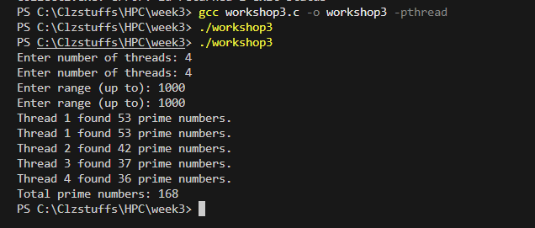
4. Convert the program in (3) to use pthread_cancel() to cancel all threads as soon as the 5th prime
number has been found.
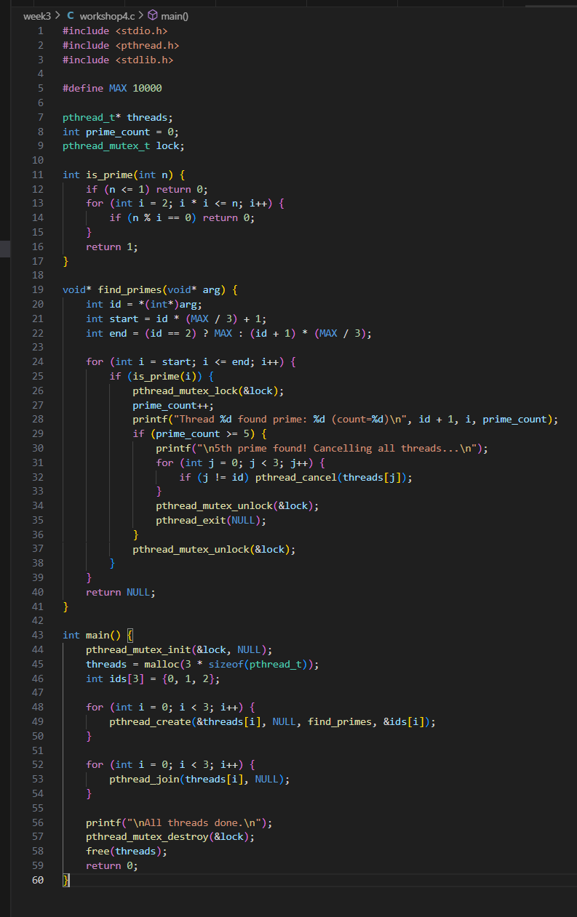
Output
